WHAT MAKES A HERO? Name(s): _________________________
INSTRUCTIONS: Use the model with Elie Wiesel to guide your own selection of a modern hero. Complete the column on the right.
COMPONENT | HERO-SPECIFIC DETAILS – Elie Wiesel | HERO-SPECIFIC DETAILS – __________________________  (Modern Hero – Your Choice)
Image | 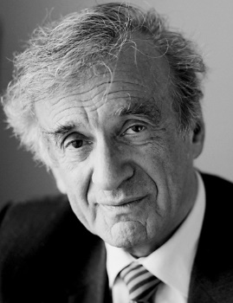
Origin Story | Born in a small city in Romania; imprisoned in concentration camps as an adolescent; survived imprisonment in Auschwitz and Buchenwald.
Super Powers/Weapon | Ingenuity; patience; survival instinct; words/writing as witness
Motivation  (Immediate motivation/ larger concern?) | Immediate – survival; processing of trauma; Larger - liberation; equality; peace; dignity
Audience  (Who is saved?) | Elie Wiesel himself ; survivors of the Holocaust; global oppressed/mistreated/hopeless – all to remember, never forget, promote understanding between cultures, offer hope
Adversary | Nazis; tendency to forget and diminish the trauma and horror of the Holocaust/WWII; hatred; bigotry; intolerance
Other Features/Factors  (EX: Kryptonite for Superman) | Nobel Peace Prize (1986)

